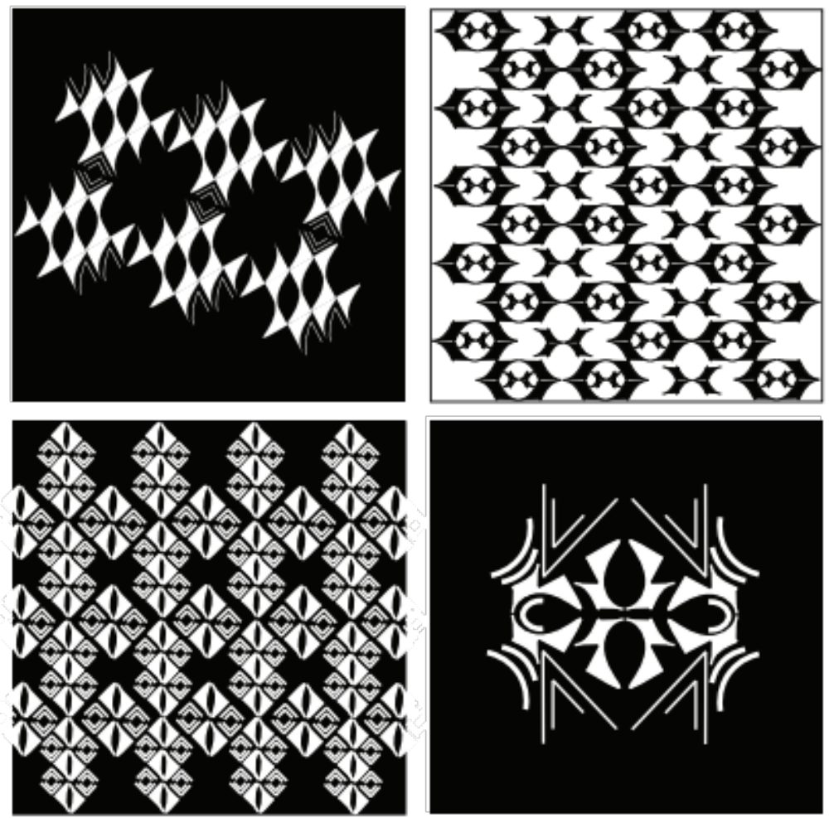

Eric Zhang, Spring 2018

AESTHETICS + SYNTHESIS
[OBSERVATION > INQUIRY > INTERPRETATION > PRESENTATION]
DISCOVERY

Foundations of Art, Design, + Digital Culture
FNAR 264-405
Tuesday + Thursday 130 – 430
Charles Addams Fine Arts Hall, Room 012
David Comberg
Comberg@design.upenn.edu
Office Hours: By Appointment
Syllabus and schedule are subject to change
Class Blog: https://2019foundations.home.blog/

Course Description
This course is an introduction to the fundamental perception, representation, aesthetics, and design that shape today’s visual culture. It addresses the ways artists and designers create images; design with analog and digital tools; communicate, exchange, and express meaning over a broad range of media; and find their voices within the fabric of contemporary art, design, and visual culture. Emphasis is placed on building visual literacy by studying and making images using a variety of representation techniques, learning to organize and structure two-dimensional and three-dimensional space, and designing with time-based and procedural media. Students learn to develop an individual style of idea-generation, experimentation, iteration, and critique as part of their creative and critical responses to visual culture.
The course is about learning to see, and make like an artist/designer. It seeks a balance between free exploration and discovery within parameters. The course focuses on design as both a mental discipline and a set of skills; as both a process and a focused practice. It positions art and design as a state-of-mind: speculative, critical, and a form of inquiry. The course should prepare students to:

• think clearly, critically and creatively about visual design
• research and analyze design problems thoroughly and from multiple perspectives
• develop concepts and multiple project proposals, focusing on quality and quantity
• speak critically about art and design, both your own design and the work of others
• take creative risks and sustain curiosity
• create with a variety of digital and manual tools
• continue studies in related fields

The course will serve as a laboratory for rigorous, directed investigation and creative problem solving. Students will study and explore through making, developing preliminary plans and drawings and refining work for presentation in a variety of media. Students must keep an up-to-date sketchbook or visual diary of progress and will produce a number of short exercises and larger projects. A portfolio, showing both finished works and the process through which that work was developed, will be due at the conclusion of the course. Course work will follow a general model of observation, inquiry, interpretation, and presentation. Class time will be used for project work, gallery visits, short presentations, discussion, and critiques. Plan on spending approximately 6 hours per week outside of class working on projects, attending tutorials, etc.

Course Requirements
• Attend all classes on time and prepared to work
• Complete all assignments fully, and on time
• Participate in critiques, explaining and justifying work and offering criticism of other students’ work
• Use your sketchbook as a journal, testing out ideas, taking notes on readings, etc.
• Submit completed projects to Course Folder on FNAR server (Juno) and course blog on date due
• Complete readings (discussion leaders) and participate in discussion and class blog (1 post/week)
• Turn in a portfolio of course-work on the last day of class
• Social media, email, text, food and drinks: be considerate and responsible
Discussion Leaders
Each project has a related reading. Discussion group leaders will be responsible for summarizing themes, relating to studio in an engaging manner, raising questions, moderating discussion.

Grading
Each project will be evaluated using a system following this criteria.
Design: Design and image-making decisions; student exhibiting understanding of design principles focused in/on a particular project.
Effort: Ambition, energy, intensity, research, participation: consistently submitting your best work, attending tutorials, bringing in research, completing assigned readings, speaking in terms relative to design principles, etc.
Concept: Idea generation, development & execution, keeping an up-to-date sketchbook/visual diary.Your journals will act as a ledger documenting your thinking. Take joy and pride in maintaining this collection of ideas.
Creativity: Invention and experimentation
Professionalism: Accuracy, craft, presentation, timeliness. *Late work rarely accepted. Incompletes rarely given. If you have extenuating circumstances any time during the semester notify me.
Grade Breakdown
15% Project 1 - What is an Image? (1.1, 1.2, 1.3 each are worth 5%)
20% Project 2 – Representation/Animation ( 2.1=5%, 2.2=15%)
20% Project 3 - Data Portrait as Sculpture
20% Project 4 - Final Project: The Public Space
10% Project 5 - Final Digital Portfolio/Sketchbook
15% Class/Critique/Blog Participation
In addition to these requirements, four absences results in one half letter grade drop in final grade (.5). The SAS grading system is as follows: A+/ A= 4.0, A- = 3.7, B+ = 3.3, B = 3.0, B- = 2.7, C+ = 2.3, C = 2.0, C- = 1.7, D+ = 1.3, D = 1.0, F = 0.0. See the SAS web site for more information. I will schedule a short meeting with each student at mid-semester to discuss work to date, progress, and grade. Please see me if you have any questions about grading. Grades with feedback will be given back to students within two weeks of handing in assignments.
Per UPenn School of Design policy, grades cannot be emailed to students
Extra Credit
Got an interesting proposal for additional course work, talk to me.

Critique/Participation/Blog
The critique is a means toreceive feedback on your work and to give feedback to others. The critique should be an open exchange to speak clearly about your work and an opportunity to explore how to give and receive feedback. I suggest, as we respond to work in in the critique, that rather than judging—“I like this or I’ve heard that this is good or bad”—that we simply ‘receive’ the work and question it, approaching the critique as a process of becoming familiar.
You are expected to post to the course blog once a week, or a total of at least 12 posts during the semester. This content should relate to what we are looking at over the course of the semester or related to design, art, media, architecture, film, animation, and fashion.
Tutorials (schedule is being revised)
Sun. September 8 - Illustrator I & II (3hr per session)
Session 1: 12:30pm-3:30pm
Session 2: 4pm-7pm
Sun. October 13th - Fall Break
Sun. October 20 - Photoshop I
Session 1: 1pm-3pm
Session 2: 3:30pm-5:30pm
Sun October 27 - Photoshop II
Session 1: 1pm-3pm
Session 2: 3:30pm-5:30pm
Processing tutorial #1: TBD
Processing tutorial #2: TBD

Along with the strongly suggested tutorials, there will be software demonstrations during the course, but it is your responsibility to learn the necessary skills to complete each project. Online application user manuals and help are available on all lab machines, providing an easy way to find many software answers quickly. Additional online tutorial support available on: lynda.com, Adobe.com, Vitale Digital Media Lab, YouTube, StackOverflow.com, and Google

Systems/Materials
iMac 3.4GHz Intel core i7 running Mac OS 10.13
Adobe Creative Cloud
HP DesignJet Z6200 & Z6100 42” Large Format Plotter Phaser
7760GX Color Laser Printer HP 5550 LaserJet printer
Epson Stylus Pro 4900 Printer
Epson flat bed scanners
Remote Access to Server Student allocation: 2GB on the PennDesign Server
$50 Large format printing credit
Working remotely: Adobe doesn’t always work consistently on different platforms

Required
Sketchbook - Please purchase a sketchbook from DickBlick or Plaza Arts. Any size around 5” x 8” works with at least 50 Pages (Moleskine Notebooks (Blank) are great, but inexpensive is good too). Cost: $10 - $15 depending on Quality
Dropbox/Google Drive, optional digital storage
USB/Discs - For backup media. Things and do get lost. Backup everything!
Digital camera and cable - you can also use your smartphone camera (cameras, etc. also available for loan from Weigle/Vitale, Penn Library)
Misc project materials
*For Project 4, Expect to spend around $25 for materials

Dick Blick 1330 Chestnut St (215) 525-3214 www.dickblick.com
Plaza Art Supply 3200 Chestnut Street 215-823-6893 plazaart.com

Systems Info
PennDesign systems info: https://www.design.upenn.edu/computing
PennDesign Remote Access: www.design.upenn.edu/remoteaccess
To view your printing charges see: https://www.design.upenn.edu/it/printing#page-section-1354
How to access Juno, PennDesign’s server.
Printing from Phaser and Large Format Printers in Addams https://www.design.upenn.edu/it/printing

Attendance Policy
I will take attendance regularly. You are permitted 3 excused (Illness or Family emergency) or unexcused absences from class during the term. The 4th absence, excused or unexcused, will cause your final grade to diminish by half letter grade for each day you are not in class. In addition, there are six software tutorials scheduled throughout the semester that you are strongly encouraged to attend. Your grade will not penalized for missing class for religious holidays. If you are sick or have an appointment or situation where you will not be in class, email. It’s your responsibility to make up class.
Project Summary (each project is 3-4 weeks; see blog for readings and schedule)

1. What is an Image? How Does it Mean?
Reading: Communication Models, Davis; Invisible Cities, Calvino; 2 Illustrator tutorials
Analysis of images, exploration of abstraction, basic non-objective shapes in a fixed space—three separate compositions addressing space, figure ground, relationships, reduction, symbol design, meaning, and abstraction:
1.1 Literacy 10x10” Black and White - Audio/Field Recording translation to Image
1.2 Meaning 12x12” Speculative product Instructions
1.3 Abstraction 12x12” Color Interpretation of an Invisible City from Italo Calvino
2. Representation/Animation
Reading: Nature of Representation, Davis; How to Make a Dada Poem, Tzara; Artful Accidents, Goldsmith; Animated Gif as Art? 2 Photoshop tutorials (image editing and animation)
Translate a poem into static and animated representations, exploring how meaning can be transmitted through composition, narrative, context, sequence and other design choices.
2.1 Static image translation/storyboard of poem
2.2 Animation with Audio + Credits
Midterm Reviews: TBD Individual meetings on your progress so far in the semester
3. Wearable Data Visualization
Reading: Form + Code in Design, Art, and Architecture, Reas; Artistic Data Visualization, Wattenberg; Processing charrette and tutorials (intro and working with data)
Quantify, analyze and write Processing code to produce multiple visualizations of personal data. Output and print/transform into wearable design.
4. Public Intervention (critical dialog/design installation; group project)
Reading: Citizen Designer, McCoy; Critical Design FAQ, Dunne & Raby; What is This Thing Called Design Criticism?, Rock, Poynor
Artist Visit: TBD
Design an intervention in a specific public space, initiating a dialog using visual forms to provoke a response in the viewer: questions or thoughts, laughter, delight, re-examination of assumptions —medium is open. Photo/video documentation required.
5. Final Digital Portfolio
Design and produce a compelling visual presentation of work produced in class.
To be submitted as a PDF to Juno Course Folder.

Project Schedule
NOTE: Schedule subject to change. Readings and assignments posted and updated on the class blog.

PROJECT 1: Visual Literacy, Meaning, and Abstraction
Week 1: August 27–29
Foundations for Art, Design & Digital Culture - Introduction to Visual Literacy
Soundwalk
Week 2: September 3–5
Observing – Seeing – Analysis (Seeing visual relations)
Topics: Basic Design Elements (Dot, Line, Shape, Color, Pattern)
Reading: Communication Models, Davis
‘Image’ definition, Wikipedia; Arranging Things, Koren
Project 1.1 Assigned 8.27
September 8 - Illustrator I & II Tutorials
Week 3: September 10–12
“How do images mean?”
Topics: Semiotics, Types of Signs, Communication, Audience, Visual Culture,
Elements of visual rhetoric (Understatement, Exaggeration, Irony)
Reading: The Nature of Representation, p 32–53, Davis
Project 1.1 Due
September 15/TBD - Photoshop I Tutorial
Week 4: September 17–19
“Abstraction”
Objective: Translating from verbal to visual (for communication, self-expression, critique, storytelling)
Topics: Objectivity, Subjectivity, Denotative, Connotative, Symbols, Symbolism
Project 1.2 Assigned
September 22/TBD - Photoshop II Tutorial
Week 5: September 24–26
“Representation”
Objective: How to Make Images? (raster, vector, procedural)
Topics: Visual organization, strategies, creating visual relations
Project 1 critique | Project 2 begins: Transition week – Finish/critique Project 1
Project 1.2 Due, Project 1.3 Assigned

PROJECT 2: Representation/Design
Week 6: October 1–3
Studio
Objective: Visual Design, Composition, Layout, Grid
Topics: Symmetry, neg/pos, contrast, boldness, order, juxtaposition
Project 1. 3 Due, Project 2 Assigned
Week 7: October 8 October 10 - No Class Oct 10/Fall Break
Studio
Moving-image (time-based, frame-based, programmable image)
Topic: Understanding the frame, sequence of frames, GIF animation.
Project 2.1 Due

Week 8: October 15–17
Studio
(Introduce Project 4 - Assign Groups)

PROJECT 3: Digital Culture/Data Portrait
Week 9: October 22–24
Project 2 Due and Critique, Project 3 Assigned
“Digital Culture I” Objective: Data Culture, How to Make Procedural Images
Processing Tutorial 1 |TBD
Week 10: October 29–31
Making images with data, rules and generative procedures.
Folding Paper Tutorial / Public art Lecture
Processing Tutorial 2 | TBD
Week 11: November 5–7
“Digital Culture II”
Objective: Information Design/Visualization/Mapping
Topics to cover: Collecting, organization, and visualization data
(Project 4 - Pitches Due - Send to Facilities)
Week 12: November 12–14
Studio
Project 3 Due and Critique

PROJECT 4: Intervention In The Public Space
Week 13: November 19–21
Installation/Documentation Challenges and Methods
In-Class: Adobe Premiere Tutorial / Tiny Monuments
In-Class: Adobe Premiere Tutorial/Archival Material and Sound Exercise
Week 14: November 26 November 28 - No Class Nov 28/Thanksgiving Break
Studio - Public Work Executed / In Class Editing/ Artist Visit: TBA
Week 15: December 3–5 (last class)
Project 5 - Digital Portfolio Assigned
Week 17: December 19 Final Critique, Project 4 due: Digital Portfolio

Tentative Assignment and Critique Schedule
Assigned Due
Project 1.1: August 27 September 10-12
Project 1.2: September 17 September 26
Project 1.3: September 26 October 1-3
Project 2.1: October 3 October 10
Project 2.2: October 3 October 24
Project 3: October 24 November 14
Project 4: October 17* December 19
Final Portfolio: December 3 December 19

*Project 4 begins early due to proposal approval time

Reference Books
Design Basics, David Lauer, Wadsworth, 1999
Form+Code, Casey Reas, Princeton Architectural Press, 2010
Designing Programmes, Karl Gerstner, Lars Muller, 2007
Principles of Two-Dimensional Design, Wucius Wong, Van Nostrand, 1972
Creative Code: Aesthetics + Computation, John Maeda, 2004
Design by Numbers, John Maeda, MIT Press, 1999
Abstracting Craft: The Practiced Digital Hand, Malcolm McCullough, MIT Press, 1998
Basic Design: The Dynamics of Visual Form, Maurice de Sausmarez, Design Press, 1980
Typographie: A Manual of Design, Emil Ruder, Verlag Niggli, 1967
Ways of Seeing, John Berger, BBC/Penguin, 1972
Abstraction in Art and Nature, Nathan Cabot Hale, Dover, 1993
Graphic Design Theory, Meredith Davis, Thames & Hudson, 2012
Introduction to Two-Dimensional Design, John Bowers, 2008
Thinking With Type, Ellen Lupton, 2010

Student Property
Work produced in courses at the School of Design is the property of the student. By participating in a course each student grants the School of Design a non-exclusive right and license to use, copy, distribute, display and perform such work in any and all media for educational, programmatic and/or promotional purposes. The School of Design will exercise care with respect to student-created materials submitted in conjunction with a course; however, the School of Design does not assume liability for their loss or damage. From PennDesign Student Handbook

Academic Integrity Policy
The University Code of Academic Integrity is central to the ideals that undergird this course. Students are expected to be independently familiar with the Code and to recognize that their work in the course is to be their own original work that truthfully represents the time and effort applied. Violations of the Code are most serious and will be handled in a manner that fully represents the extent of the Code and that befits the seriousness of its violation.

The Code of Academic Integrity is available online at:
https://catalog.upenn.edu/pennbook/code-of-academic-integrity/

Notice of Inclusion
The Fine Arts Department is committed to maintaining an inclusive and welcoming community. We will not tolerate under any circumstances any hate speech or intimidation in or around our classrooms or buildings.

Undergraduate Majors in Fine Arts and Design
Please see me or this site for information about the new Undergraduate Fine Arts Design Major
https://www.design.upenn.edu/fine-arts/undergraduate/design

